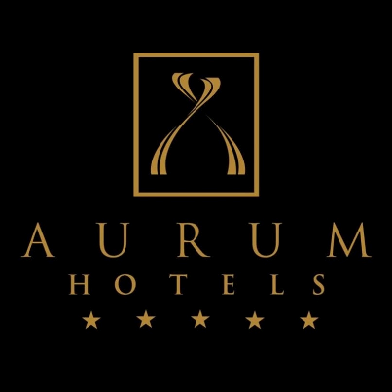

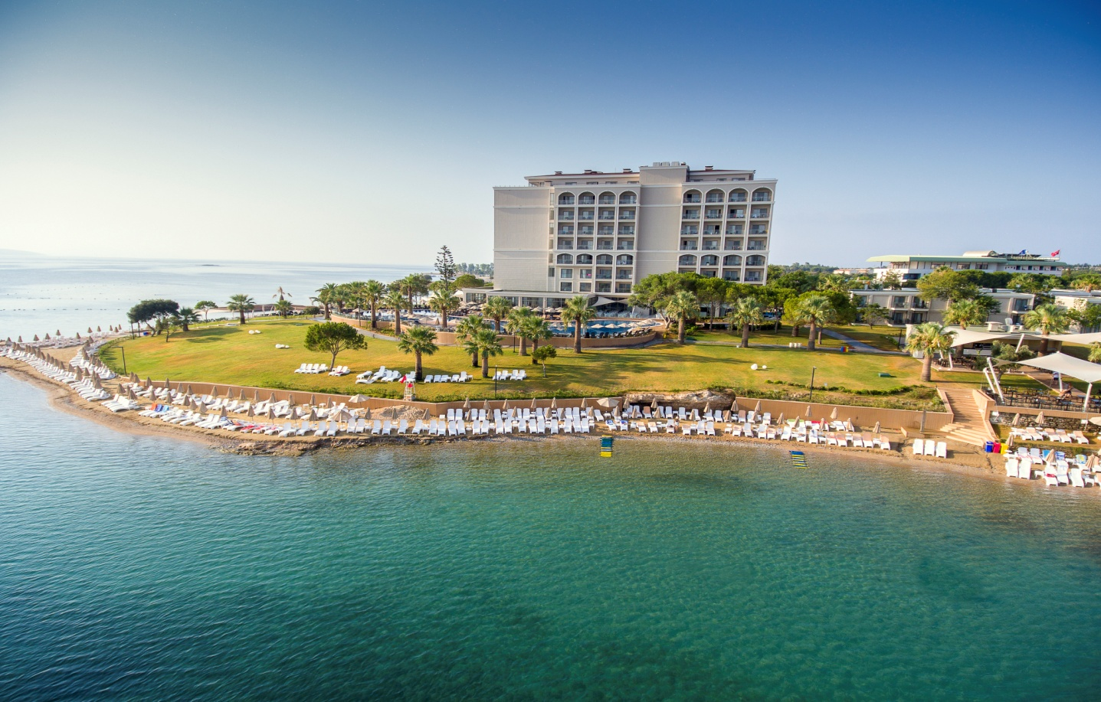

AURUM MOON RESORT
09270 DİDİM
Aydın- Didim / TÜRKİYE
Tel. : +90 256 835 34 34

Fax : +90 256 835 33 99

WEBSİTE ADDRESS
www.aurumhotels.com.tr

E-MAİL ADDRESS
info@aurumhotels.com.tr

CATEGORY

5 Star Resort Hotel

Accomadation Style

Ultra All Inclusive

Season

Summer Season

Opening Date
April 2016

VOLTAGE
220 v

Accepted Credit Cards

Visa, Master Card,

Location

Didim Altınkum , Yeşilkent. Over 55000 m2 area set on a natural site in a beautiful position.

Distance
Didim City Centre : 5 km.
Bodrum - Milas Airport : 70 km.
İzmir Airport : 125 km
Taxi : Hotel Entrance
Bus Stop : 200m proximity to hotel.

ROOMS

All rooms and services offered:
All rooms have been designed with a special architectural concept, you will find in all rooms an electronic door lock system and fire alarm. All of our rooms have mini-bar, kettle, tea and coffee set, LCD television with international TV channels, satellite channels, music channels (TV channel), childrens channels, WC, shower, bathroom, direct dial telephone, central air conditioning system (air conditioning working hours are determined by the hotel according to weather conditions), single or double bed, electronic safe, balcony or terrace, hair dryer, vanity mirror, towels, slippers, quality toiletries, rooms have parquet flooring.

Free services:
Safe deposit box, Linen change every other day (optional), all VIP rooms and Suite rooms daily change service ( turn down service), daily towel change, daily room clean, mini-bar daily replenishment (once), tea-cofee daily replenishment (once).

Total number of rooms : 454
Total number of beds : 1036

Room Types

Standard room (sea view / land view rooms)
239 rooms 28m2. Double bed or two single bed options available. All our standard rooms with double beds have 1 single person sofa bed. The room consists of 1 bathroom and balcony. All Standard rooms are located in two seperate 6 storey blocks.

Club Standard room
98 rooms 28 m². 1 bedroom: 1 double bed and 1 single person sofa bed. The room consists of 1 bathroom and balcony. Located in 2-storey Club Room block.

Club Junior Suite room
50 rooms 28 m². 1 bedroom, 1 sitting room, 1 double bed, 2 single person sofa bed. 1 bathroom and balcony. Located in the Club room block. These have one seperate doors.

Club Family Room
48 rooms 28 m² . 1 bedroom, 1 childrens bedroom, 1 double bed, 2 single beds. 1 bathroom and balcony. Located in the Club room block. These have two seperate doors.

Club Suite Room
16 rooms 50 m². 1 bedroom, 1 childrens bedroom, 1 sitting room and 1 bathroom. 1 double bed, 2 single beds, 1 single person sofa bed. All rooms are located in the club room block.

Disabled Room( standart room)
5 rooms, 28 m². Two single bed options are available for the room. It consists of 1 bathroom.

RESTAURANT AND BAR

Food Options:
Restaurant | Food Concept | Service hours and presentation |  | Capacity | Music / Theme | Explanation
Main restaurant | Open buffet | Breakfast  Late breakfast  Lunch Evening food  Night buffet | 07:00-10:00  10:00-11:00  12:30-14:30  19:00-21:30  23:00-01:00 | 700 | International Night Theme | Reservation not required  Free of charge
Nahm Turkish  A La Carte  restaurant | A La Carte | Evening food 19:00 - 22:00 |  | 40 | Turkish music | If you stay a minimum of 7 nights, you get one free evening at this restaurant.  Reservation required.
Sake Far East Restaurant | A La Carte | Evening food 19:00–22:00 |  | 30 | Far East music | Optional Chargeable
Cento Italian  A La Carte  Restaurant | A La Carte | Evening food 19:00 – 22:00 |  | 80 | Italian music | If you stay a minimum 7 nights, you get one free evening at this restaurant. Reservation required.
Auqa Sea Food  A La Carte | A La Carte | Evening food 19:00 – 22:00 |  | 80 | International music | If you stay a minimum of 7 nights, you get one free evening at this restaurant.  Reservation required.
Snack  ( SNACK RESTAURANT) | Mini Buffet | 12:00-16:00 |  | Free
Turkish Pancake |  | 11:00 – 16:00 |  | Free
Patisserie |  | 11:00- 20:00 |  | Free
Room Service |  | 24:00 – 06:00 |  |  | Chargeable | Food and drink menu.  Chargeable menu
Snack ( Coffee Break ) | Cake, Waffle | 16:00- 18:00 |  |  | Free | Snack Bar
• Hotel management has the right to decide if neccessary to close any bar or restaurant dependent on weather conditions, and demand.

Drink Options :
Outlet | Service hours and presentation | Drink Concept
Lobby Bar ( Moon Light Bar) | 24 hours open / drink | Some of import drinks and alcholic and non-alcholic drinks
Snack Bar | 10:00 - 22:30 / drink | Alcholic and non-alcholice drinks
Arena Beach&Disco Bar | 16:00 - 02:00 / drink | Alcholic and non-alcholic drinks
Spa Vitamin Bar | 09:00 - 19:00 / drink | Hot drinks(tea, coffee), Water
Patisserie Cafe & Bar | 09:00 - 24:00 / drink | Hot drinks, Water
Roof Bar | 18:00 - 24:00 / drink | Alcholic and non-alcholic drinks
Room Mini Bar | Once a day - still water / sparkling water free of charge | Still/Sparkling water
Room Maxi Bar | Optional  Chargeable | Cola, Cola Zero, Fanta, Sprite, Fruit juice, Beer, Crisps, chocolate
Room Service | 24:00 – 06:00 | Food and drink menu  Chargeable menu

Food and Drink options

Free Services:
• Welcome cocktail, under 18 years of age fruit juice, special turkish delight.
• Special suprise for small guests in reception upon arrival to hotel.
• All Inclusive packet starts from check-in at 14.00hrs and finishes at 12.00hrs on date of departure.
• Mini bar (Once a day free still/sparkling water)
• All rooms have a kettle with tea and coffee sets available( once a day replenished)
• Meal time drinks will be served by our waiters.
• Alcholic drinks will not be served to persons under 18 years of age.
Breakfast, Lunch and Evening meals available during the restaurant and bar opening hours. Also the 24 hour Lobby Bar serves national and some import alcholic and non-alcholic standard beverages served. Breakfast buffet, late breakfast, lunch, dinner and late night dining are all served in open buffet style in the main restaurant.
• Grill choices in the main restaurant,
•Diet and healthy food section in the main restaurant;
• Pancakes (turkish gözleme)
• The main restaurant has microwave oven, blenders and bottle warmers for children;
• Snack restaurant serves fast food, and other snacks available.
• Main restaurant serves ice-cream during the evening buffet;
• Themed music played in the A La Carte restaurant

Chargeable Services:
• All bottled alcholic beverages, all special request drinks, imported wines and champagne(menu), premium alcholic beverages (10 and 12 years and above VSOP , XO Cognac );
• In our A La Carte restaurants, cover charges are required (reservation required), with the exception of three A La Carte restaurants. If your reservation is cancelled, (deposit given) you must notice the hotel no later than 16.00hrs on the day of your reservation. A La Carte service time 19.00 – 22.00.
• Special food order and beverages, including wines and champagne, if they are not listed in the A La Carte restaurant menu, they will be provided with a charge.
• A La Carte restaurant ( chargeable) 0-6 years free of charge, 7-12 years 50% discount.
• Room service
• Lunch Box service

Special Day

Free Services:
• Special service for Honeymoon couples; VIP welcome, rooms with special themed decoration (Special linens, bathrobes, slippers ) entry day wine and fruit basket, a once –off A La carte restaurant decorated table at dinner, surprise cake, once -off breakfast to your room, one memoriable photo.
• Special service for Birthday and Wedding Anniversary, wine and mini cake refreshments delivered to the room.

Chargeable Services:
• All invitation, banquet and organizational services if required.
•. Special cake orders and special day celebration packages.

ENTERTAINMENT, ACTIVITY & LEISURE TIME

Here at Aurum Hotel, we offer our guests a holiday to remember with our animation program that appeals to both adults and childrens during their stay. Our guests will not only enjoy the sea and sun, sports and participate in recreational activities themselves, water sports, yoga, will be able to try activities such as gymnastics. Our professional team at Aurum has colourful and creative organization skills. Aurum Hotel entertainment and quality philosopy will fill your nights.

ENTERTAİNMENT

Free Services:
• Daily activities and night shows by the Anşmation team
• Themed parties
• Swimming Pool activities
• Live music
• Disco
• Backgammon, chess, card games
• Library
• Karaoke
• Wireless internet in communal areas

CHİLDRENS ENTERTAİNMENT AND AURY MİNİ CLUB

Aury Mini Club is waiting for you! Family members of young children can register for the childrens club at reception. Daily activity programmes within a fun and safe environment.Age specific activities including face painting and themed days.
Every evening Mini Disco 20:30- 21:15, Interactive daily shows start during the day and finish with stage shows in the evening.

Free :

• Mini club(04-12 yrs)
• Mini disco
• Mini cinema
• Mini shows
• Daily different themes
• Development games and activities
• Play Ground(open air)
• Mini Club Hours: 10:00- 12:30 and 14:30- 17:30

BABY SERVİCES

Chargeable Services:
• Child Minder (over 1years of age, reservation required)
• Baby Monitor, Baby Stroller,
• T-shirt and sand painting
• Play station, Video and Computer games .
• Happy Baby room*

Happy Baby Room
• Baby stroller
• Baby monitor
• Bottle warmer and feeding chair
• Baby kit ( shampoo , talc , lotion, wet wipes, bath sponge )
• Thermomether
• Baby bath
• Baby toilet seat or potty
• Baby linen ( Pillow and duvet. Quilts and blankets)
• Baby crib( play area)
***Optional. Chargeable.

SPORTS ACTIVITIES

Free of charge:
• gymnastic
• Yoga
• Water polo
• Aerobic
• Water gymnastics
• Table tennis
• Badminton
• Boccia
• 1 Tennis courts, 1 Basketball courts
• Modern Fitness centre

Chargeable:
• All kind of water sports
• Scuba diving

Health & Beauty Services

Free of charge:
• Turkish Bath
• Sauna
• Resting Room
• Steam Room

Chargeable Services:
• Peeling, foam massage and all kinds of massage
• Wellness center, skin and body treatments
• Hairdresser
• Doctor services

OTHER SERVİCES

Free Services:
• Message services
• Porters
• Parking services
• The main restaurant reserves daily tables for guests with disabilities
• Wheelchairs for the disabled ( companion required)

Chargeable Services:
• Telephone, fax
• Laundry ( dry cleaning, washing , ironing and tailoring )
• Baby stroller, Bicycle, Vehicle hire
• Electronic equipment provided in meeting rooms
• Transfer services
• Freshly squeezed juices for breakfast
• Smoking Pıpe (Nargile)
• Photography services

Shopping :
• Leather
• Photo
• Market
• Motorised water sports
• Gift shop

MEETING ROOMS

Room Name | Width | Height
L Meeting Room | 180 m² | 2,80m
H Meeting Room | 140 m² | 2,80m

 | Theater | Class | Banquet | U Design
L Meeting Room | 150 px | 84 px | 84 px | 46 px
H Meeting Room | 130 px | 78 px | 78 px | 40 px

BEACHES AND SWIMMING POOLS

BEACH

Free services:
200m sandy beach, 350m long Platform, 3 decking areas, Total length 550 m. Beaches have WC, shower and changing cabins. All day Life Guard, Beach Bar. Beaches and pool areas have free towels and umbrellas.

SWIMMING POOLS

 | Open | Volume | Depth
Main Pool | √ | 1150 m² | 1.40 m
Aquapark Pool | √ | 153 m² | 1.50 m
Childrens Pool | √ | 80 m² | 0.40 m
Childrens Pool with Slides | √ | 100 m² | 0.40 m
Quiet Pool A Blok | √ | 85 m² | 1,40 m
Quiet Pool B Blok | √ | 85 m² | 1,40 m
Quiet Pool C Blok | √ | 85 m² | 1,40 m
Quiet Pool D Blok | √ | 85 m² | 1,40 m

• All Pools are closed between 20.00 - 08.00 for guests Health and Safety. Fresh water pools.
• Pools, aquapark, water sports, animation shows, outside A La Carte restaurants provide services dependent on weather conditions.

IMPORTANT INFORMATION

• Guests to inform Customer Relations department of any guest allergies. Otherwise, the hotel management will take no responsibility for problems that may occur .
• Dated 19.05.2008 T. C. (Republic of Turkey) According to the law in general use in indoor areas are
non-smoking .
• Pets are not allowed in our establishment.
• All facilities opening and closing hours of service both indoors and outdoors operate depending on weather conditions and seasonal needs .
• Hotel Check In time start at 14:00’ , Room Check out time at 12:00.
• Hotel determines local alcoholic / non-alcoholic drinks and some imported drinks are included .
• Hotel management reserves the right to make changes to the information provided in this document.
Ö

