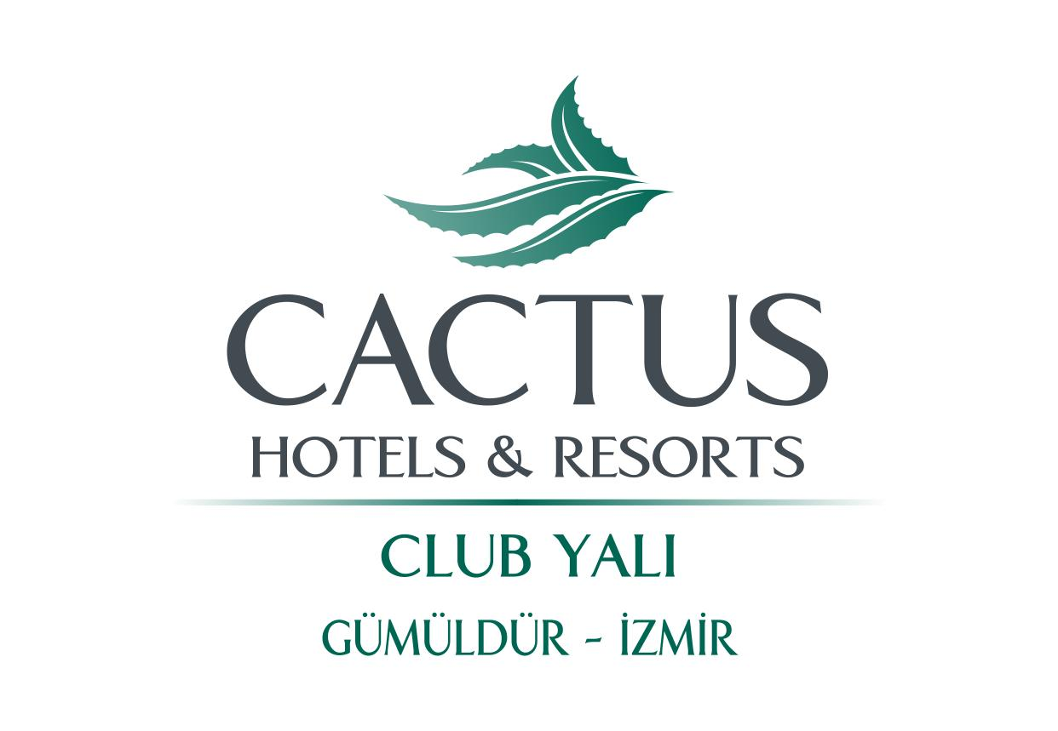

GENERAL INFORMATION

 | OFFICIAL NAME ACCOMMODATION | CACTUS HOTELS CLUB YALI RESORT
 | GPS COORDINATES * | 38.066025,27.000639
 | ADDRESS | ATATÜRK MAH SAHİL CAD NO 51 GÜMÜLDÜR İZMİR TURKEY
 | IN TOWN/CITY/VILLAGE | VILLAGE
 | PHONE NUMBER | +90 232 793 38 38
 | EMAIL ADDRESS | clubyalihotelsandresort@cactushotels.com
 | OFFICIAL CATEGORY (KEYS/STARS) | 5
 | UNIQUE SELLING POINTS | ●Directly on the beach with a Blue Flag
 |  | ● Big garden with sunbed possibility
 |  | ● Yalı Castle Aquapark free weekdays between 1st of june 15 September
 |  | ● Very good / satisfying All inclusive concept
 | MOST IMPORTANT TARGET GROUPS | YOUTH / COUPLES /FAMILIES
 | YEAR OF CONSTRUCTION | 2000
 | YEAR/SEASON OF LAST RENOVATION | Every year
 | RENOVATED AREAS | Restaurant – heated pool – handicapped rooms – chd playground – mini club
 | TOTAL NUMBER OF BUILDINGS | 2 main buildings + 2 parts of bungalows
 | MAXIMUM NUMBER OF FLOORS | 4
 | TOTAL NUMBER OF ROOMS | 450
 | TOTAL NUMBER OF LIFTS | 4
 | LIFT IN EVERY BUILDING | 2
 | RECEPTION | 24/7
 | PETS ALLOWED | NO
 | LOBBY | yes
 | GARDEN | yes
 | WHEELCHAIR FRIENDLY | yes | .
 | LOCATION
ON THE SEA (WITH PRIVATE BEACH) |  | yes
NEAREST TOWN/CITY |  | NAME OF TOWN/CITY: Gümüldür 3 km.
TYPE OF BEACH (SAND, ROCKS ETC…) |  | Sandy beach
PUBLIC TRANSPORT IN MTRS/KM |  | BUS: yes 200 m.
 |  | TAXI: yes 0 m.
ROOM FACILITIES
HOTEL ROOM

NAME OF ROOM TYPE | Standard Double Room Land view or Sea view
MINIMUM MAXIMUM OCCUPATION | 1 - 3
SIZE IN SQUAREMETRES | M2: 17
SEPARATED LIVING ROOM | NO
TELEPHONE | YES
AIRCONDITIONING | YES FREE
TELEVISION | YES SATELLITE
MINIBAR | YES with charge
SAFE | YES with charge
WIFI IN ROOM/APPARTMENT | NO
BATH TUB | YES
HAIR DRYER | YES
BALCONY OR TERRACE + CHAIRS | YES
VIEW | LAND OR SEA ( SEA WITH CHARGE)
 | CENTRAL AIR CO

HOTEL ROOM

NAME OF ROOM TYPE | Family Room Land view or Sea view
MINIMAL MAXIMUM OCCUPATION | 2 - 4
SIZE IN SQUAREMETRES | M2: 32,5
SEPARATED LIVING ROOM | YES
TELEPHONE | YES
AIRCONDITIONING | YES FREE
TELEVISION | YES SATELLITE
MINIBAR | YES with charge
SAFE | YES with charge
WIFI IN ROOM | NO
BATH TUB | YES
HAIR DRYER | YES
BALCONY OR TERRACE + CHAIRS | YES
VIEW | LAND OR SEA ( sea with charge)
 | Central air co

CLUB ROOM

NAME OF ROOM TYPE | Club Standard Room
MINIMAL MAXIMUM OCCUPATION | 1 - 3
SIZE IN SQUAREMETRES | M2: 21
SEPARATED LIVING ROOM | NO
TELEPHONE | YES
AIRCONDITIONING | YES FREE
TELEVISION | YES satellite
MINIBAR | YES with charge
SAFE | YES with charge
WIFI IN ROOM | NO
BATH TUB | YES
HAIR DRYER | YES
BALCONY OR TERRACE + CHAIRS | YES
VIEW | Land view
 | Club rooms with split air conditioning

CLUB ROOM

NAME OF ROOM TYPE | Family Room
MINIMAL MAXIMUM OCCUPATION | 2 - 4
SIZE IN SQUAREMETRES | M2: 32,5
SEPARATED LIVING ROOM | YES ( 2 SLEEPİNG ROOMS SEPERATED WİTH A DOOR )
TELEPHONE | YES
AIRCONDITIONING | YES free
TELEVISION | YES satellite
MINIBAR | YES with charge
SAFE | YES with charge
WIFI IN ROOM/APPARTMENT | NO
BATH TUB | YES
HAIR DRYER | YES
BALCONY OR TERRACE + CHAIRS | YES
VIEW | GARDEN VİEW
 | Club rooms with split air conditioning

FOOD & BEVERAGE FACILITIES

RESTAURANTS | NAME OF RESTAURANT | BUFFET OR À LA CARTE | TYPE OF DISHES / THEMES | INCLUDED IN CONCEPT
RESTAURANT #1: | MAIN RESTAURANT | BUFFET | INTERNATİONAL | YES
RESTAURANT #2: | TURKISH CUISINE | BUFFET ONLY LUNCH | TURKISH FOOD | YES ( EXCEPT RAIN)
RESTAURANT #3: | FİSH RESTAURANT | FIXED MENU / DINNER | FISH | ONLY HIGH SEASON
RESTAURANT #4: | ITALIAN TESTAURANT | FIXED MENU / DINNER | ITALIAN | ONLY HIGH SEASON
REMARKS | FİSH AND ITALIAN WİTH RESERVATİON AND 1 x STAY

BARS | NAME OF BAR | SELF SERVICE YES/NO | THEME/SNACKS/POOL | INCLUDED IN CONCEPT
BAR #1: | LOBBY BAR | YES |  | YES
BAR #2: | RESORT POOL BAR | YES | POOL | YES
BAR #3: | CLUB POOL BAR | YES | POOL | YES
BAR #4: | BEACH BAR | YES |  | YES
BAR #5: | TREE BAR | YES |  | ONLY NİGHT TİME
BAR #6: | SNACK BAR | YES | SNACKS LUNCH TIME | YES
REMARKS | TREE BAR ONLY HIGH SEASON. ALL IN 20:00 – 00:00

CONCEPT

ALL INCLUSIVE CONCEPT | HOURS | BUFFET, À LA CARTE, SELF SERVICE
BREAKFAST | 07:00 – 10:00 | BUFFET
LATE BREAKFAST | 10:00 – 11:00
LUNCH | 12:30 – 14:30 | BUFFET
DINNER | 19:00 – 21:30 | BUFFET
SNACKS | 12:00 – 15:00
COFFEE, TEA & COOKIES | 16:30 – 18:00
ICE CREAM | DURING BUFFET
LOCAL SOFT- & ALCOHOLIC DRINKS | 10:00 – 00:00
IMPORT DRINKS | SOME
NOT INCLUSIVE | IMPORTED DRINKS

SWIMMING POOL FACILITIES

POOLS | FRESH | HEATED | SLIDES
POOL #1: | FRESH
POOL #2: | FRESH |  | SLIDES
POOL #3: | FRESH
POOL #4: | FRESH | YES

CHILDREN POOLS | FRESH OR SEA WATER | HEATED | SLIDES
POOL #1: | FRESH
POOL #2: | FRESH
POOL #3: | FRESH

LOUNGERS | YES FREE
MATRESSES | YES FREE
SUNSHADES | YES FREE
TOWELSERVICE | YES CHANGE WİTH FEE
BEACH FACILITIES

PRIVATE BEACH | YES
LOUNGERS | YES FREE
MATRESSES | YES FREE
SUNSHADES | YES FREE
INTERNET FACILITIES

WIFI PUBLIC AREAS | YES FREE AREAS : GARDEN + LOBBY
INTERNETCAFE | YES FREE
REMARKS | NO WIFI IN THE ROOMS
KIDS FACILITIES

CLUB & ENTERTAINMENT | AGES | NUMBER OF DAYS A WEEK | LANGUAGES
MINICLUB | 04 - 12 | 6 | ENG / FRENCH / TURKISH / GERMAN

MINIDISCO | YES
PLAYGROUND | YES
BABY COTS | REQUEST AT BOOKING REQUIRED: YES | FREE

SPORT, RECREATION & RELAXATION FACILITIES

SPORT | YES/NO: | FREE/PRICE:
AEROBICS | YES
BASKETBALL | YES
BEACH VOLLEYBALL | YES
BILJART | YES
BOCCIA / PETANQUE / JEU DE BOULES | YES
DARTS | YES
DIVING CENTRE |  | OUTSİDE WİTH FEE
FITNESS / GYM
TABLE TENNIS | YES
TENNIS | YES
VOLLEYBALL
WATERSPORTS | YES | OUTSOURCE WİTH FEE

RELAXATION | YES/NO: | FREE/PRICE:
BEAUTY TREATMENTS | YES | FEE
HAMAM | YES
INDOOR POOL | YES
MASSAGES | YES | FEE
SAUNA | YES | FEE
HAIRDRESSER | YES | FEE

ENTERTAINMENT | YES/NO: | NUMBER OF DAYS A WEEK
FOR ADULTS | YES | 7
SHOWS | YES
LIVE MUSIC | YES | 1

OTHER : DRINKS AT DISCO, MEDICAL SERVICE, LAUNDRY WITH FEE

